**Overview of Programming and Problem Solving Walkthrough with Figures from**

**“Programming and Problems Solving with C++” - Dale and Weems required textbook**

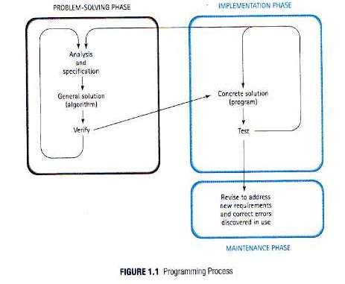

**The Programming Process**

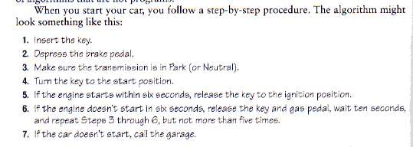

**The most fundamental concept of computer science is that of understanding, writing and using algorithms.**

**Algorithm: Is a set of steps that defines how a task is performed. More precisely, an algorithm is an ordered set of unambiguous, executable steps that define a terminating activity.**

**The study of algorithms began as a subject in mathematics long before today’s computers. A major goal of mathematicians was to find a single set of directions that described how any problem of a particular type could be solved. The long division algorithm for finding the quotient of two multiple-digit numbers is one such example and another is the Euclidean algorithm, discovered by the ancient Greek mathematician Euclid, for find the greatest common divisor of two positive numbers.**

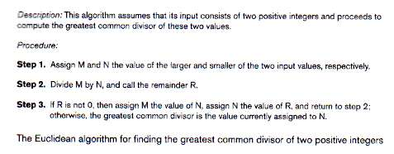

**An algorithm for perform magic tricks**

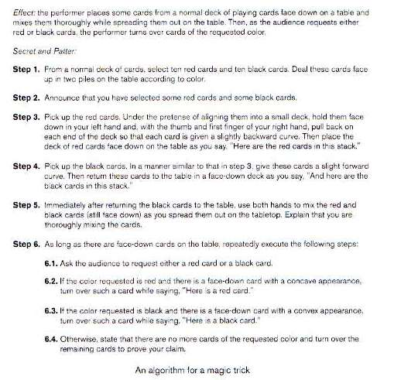

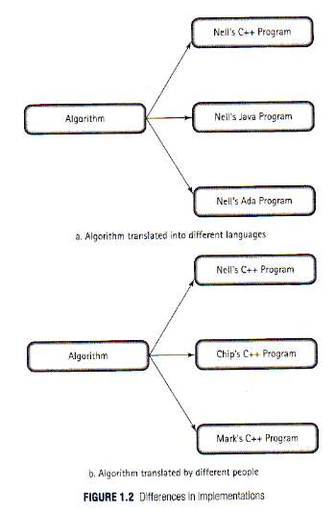

**Differences in implementation of algorithms (see pg. 5)**

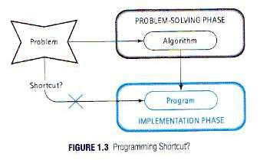

**Something not to do!**

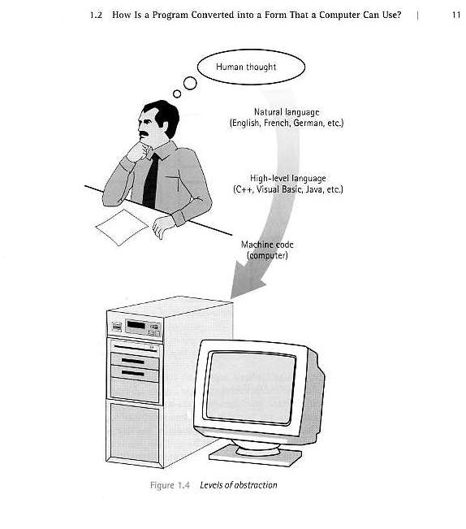

Levels of abstraction

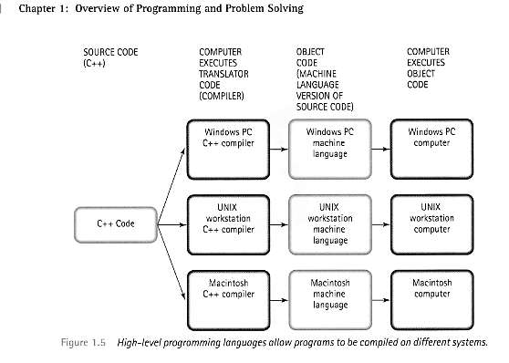

Programming languages and Operating System platforms

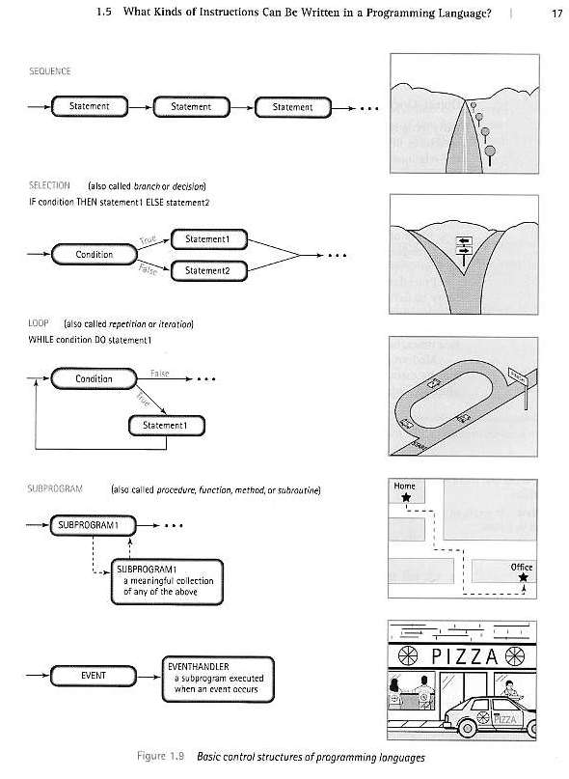

A visual look at control structures – you will be writing “logic routines” that address the various programming challenges that will appear in the upcoming assignments and projects.

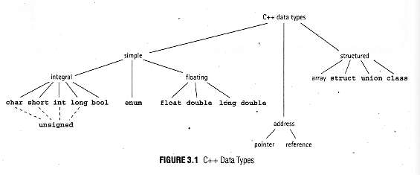

A Visual look at C++ Data Types (pre-defined or primitive) – You will have a basic introduction to data structures and work with both simple and structured types

Computer: Typical components, services and processes in a programmable electronic device

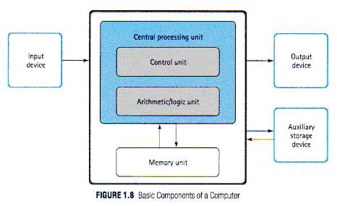

**Program code algorithms will interact with all of the above components**

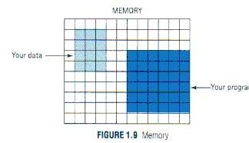  
**Program code and data is stored and allocated computer memory resources**  
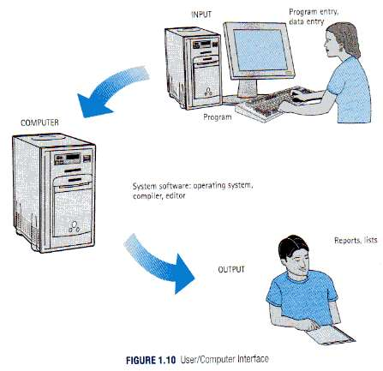  
**Program code and data is stored and allocated computer memory resources**

Problem Solving Techniques

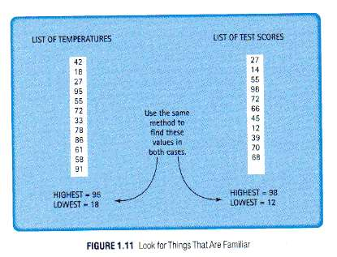

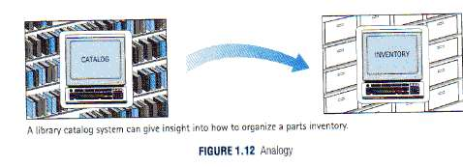

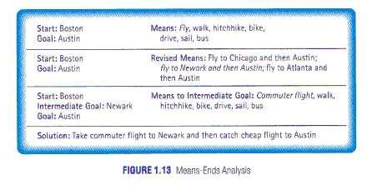

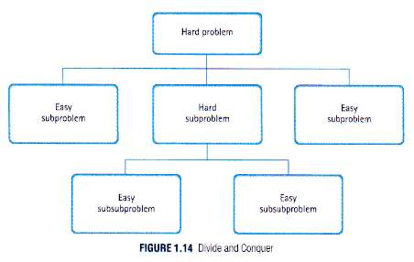

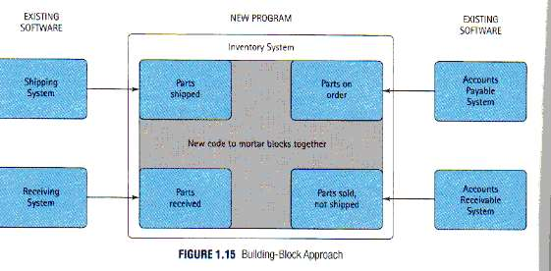

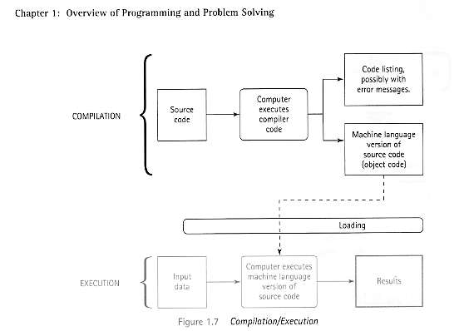

The Compilation, Debugging, Execution Process – a place where you will spend most of your time

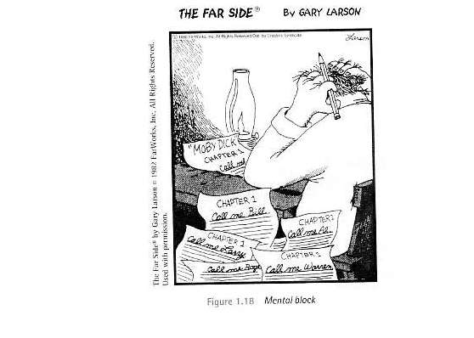

The Far Side Cartoon ....MENTAL BLOCK

**Remember there is life outside of C++ …..**